**Superimposing Line Charts with Separate Axes**

Wouldn't it be nice to have the number of themes and the number sets on the same chart? But what do we get if we just plot both of them the way we have before?

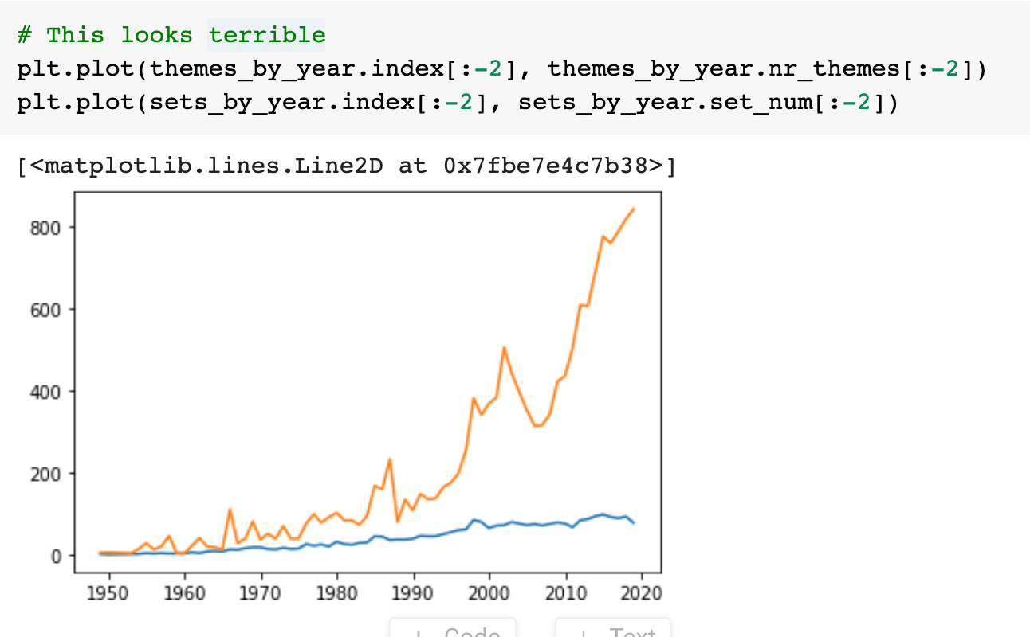

Well, that's not very informative! 🤦‍♀️ The problem is that the "number of themes" and the "number of sets" have very different scales. The theme number ranges between 0 and 90, while the number of sets ranges between 0 and 900. So what can we do?

**Two Separate Axes**

We need to be able to configure and plot our data on two separate axes on the same chart. This involves getting hold of an axis object from Matplotlib.

1. ax1 = plt.gca() # get current axes
2. ax2 = ax1.twinx()

We then create another axis object: ax2. The key thing is that by using the .twinx() method allows ax1 and ax2 to share the same x-axis. When we plot our data on the axes objects we get this:

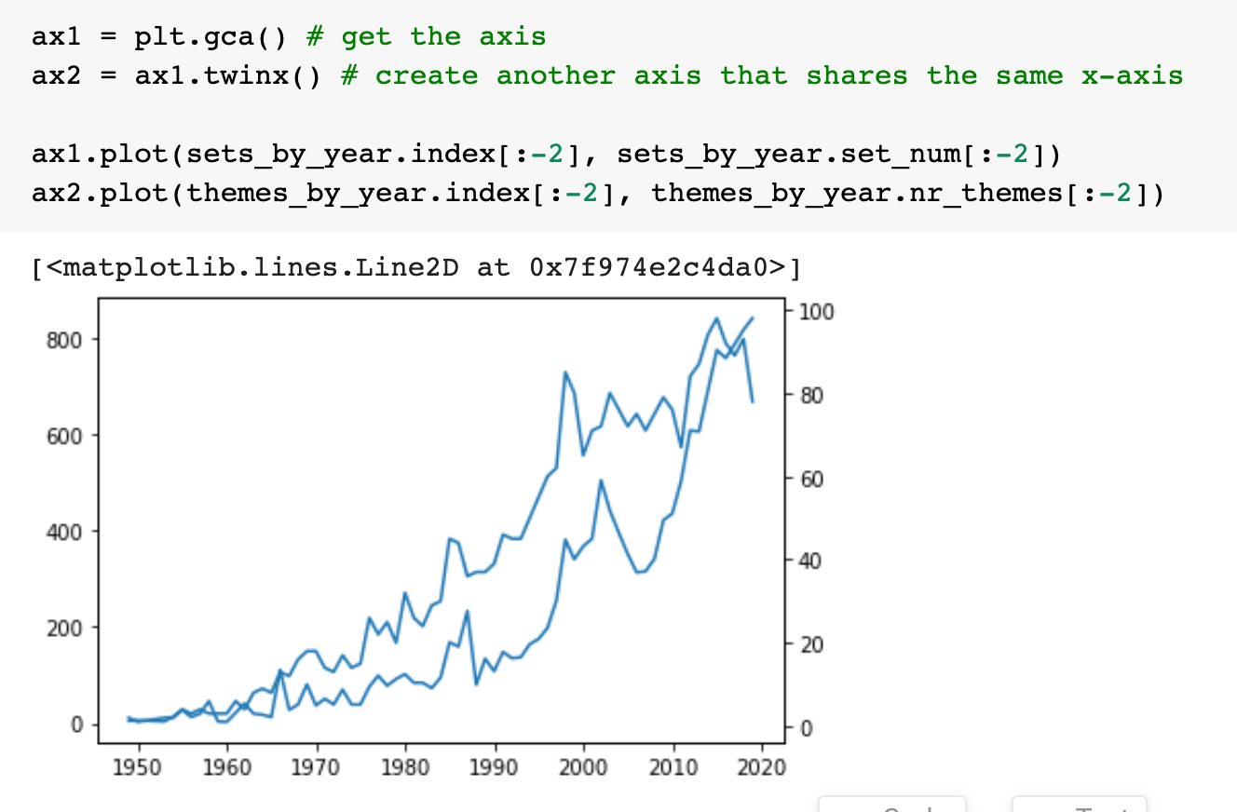

That's very nice! But there's one problem: we can't tell the lines apart because they have the same colour! Let's add some styling. Let's:

* colour in the lines
* colour in the axes and
* add some labels

so that we can see what's going on. Here's what we get:

